**Business Problem**

It is often said that great wine is made in the vineyard, not in the winery. However, winemakers have the ability to modify certain aspects of the wines they produce, such as the level of acidity, sweetness or alcohol, as well as the shelf life. But which aspects should winemakers modify to positively impact consumers’ perceptions and/or sales of their wines?

A wine company has hired you to help the organization better understand the relationships between certain physiochemical properties and the perceived quality of wines so that its winemaking team can make more informed decisions during production. You as an analyst already obtained data from a third-party industry organization and started an exploratory analysis.

**Your Objective**

Your objective is to collaborate with your supervisor to continue the analysis and to provide your company with insights on how to maximize the appeal of its wines. It’s also looking for ideas on other analyses it might conduct in the future to support the business, as well as what data would be required to run them.

To help you get started, notes on the available data and results from your predecessor’s exploratory analysis are provided on the following pages. You may use any of these results in your own presentation. The dataset, graph images are all in the project folder “Wine Quality Prediction.” Both R and Python are also available for analyzing the dataset – choose whichever program you prefer. Be prepared to make and discuss assumptions as needed. You are highly encouraged to brainstorm aloud with your supervisor while you are working.

You have two (2) hours to complete the work. The client and your supervisor understand that more time is typically needed to do a really thorough analysis, but you are expected to focus on what you think matters most in the time given. You can spend this time as you see fit, but the following allocations are recommended:

30 minutes - Data and EDA review and analytic plan development

60 minutes - Analytic plan execution, including code and output

30 minutes - Synthesis of results and presentation

Finally, your presentation does not need to be fully developed or refined, but should present any relevant insights you uncover as clearly as possible.

**Dataset**

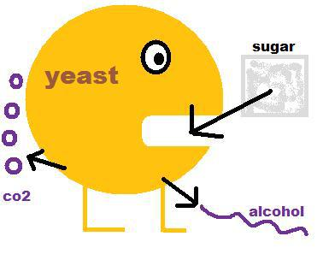

The dataset consists of 12 measurements on 6,497 samples of white and red styles of *Vinho Verde* wines. There are NO missing data. Descriptions of each variable are below.

|  |  |
| --- | --- |
| Variable | Description |
| fixed_acidity | Naturally occurring acid, higher levels yield fresher or more tart wines |
| volatile_acidity | Acid produced during fermentation, leads to unpleasant aromas |
| citric_acid | Inexpensive supplement to boost total acidity |
| residual_sugar | Remaining sugar after fermentation or sometimes added, higher levels yield sweeter wines |
| chlorides | Saltiness, often just barely detectable |
| pH | Higher levels make wines taste softer, inversely related to acidity |
| alcohol | Produced from yeast and sugar during fermentation, higher levels associated with more complex wines |
| density | Lower for "dry" wines, higher for sweet wines |
| free_sulfur_dioxide,  total_sulfur_dioxide | Antibiotics/antioxidants to protect wine and sanitize wineries; detectable as pungent odor at higher levels and responsible for label “contains sulfites” |
| sulphates | Potassium sulphate used to lower pH, raise acidity and intensify color in red wines |
| quality | Median of ratings on a 0 to 10 (poor to excellent) scale from three or more experts who participated in blind tastings |
| style | Red or white |

**Exploratory Results (work in progress)**

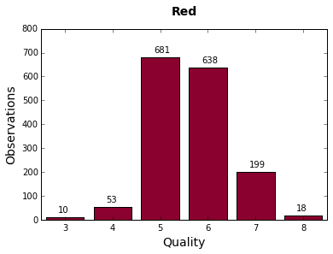 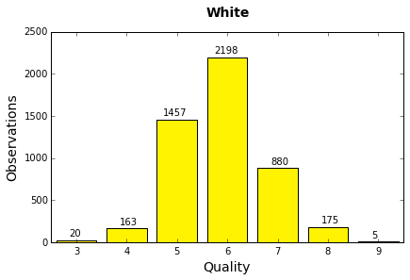

*Mean*

*Median*

